**Obstacle Avoiding Car**

**Introduction**

This obstacle avoiding machine uses an HC-SR04 sensor mounted on top of a servo to **locate walls** in a maze using echolocation. ... The Arduino, servo, and sensor are powered by a separate 9V battery. The Arduino, servo, and sensor are powered by a separate 9V battery. The car moves forward until it sees a wall that is less than 35cm away. If this condition is met, the car backs up and the servo rotates 90 degrees to the left for the sensor to scan how far away the left wall is. The servo then rotates 180 degrees to the right to scan the distance of the right wall. If the distance of the left wall is more than the right, the car will turn 90 degrees to the left

. 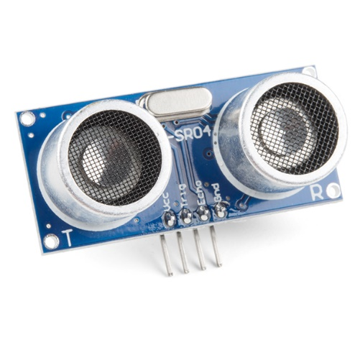

**Components**

Arduino UNO

Ultrasonic Sensor

L298N Motor driver Module

Robotics Kit (4 DC Motors, Wheels, Chassis)

Battery Pack (5V and 12V)

Application

tracking system

industrial automation

Agriculture and health care system

Objective

During this activity ,you will help students to achieve following objectives

1. Understanding the principle and operation of ultrasonic distance sensor

2. Design algorithm and flowchart to detect obstacle and get alerted

3. Programming ultrasonic distance sensor using Arduino uno

4. Interfacing ultrasonic distance sensor withArduino uno

Algorithm

1. Initialise constant integer to drive motor as IN1,IN2,IN3,IN4
2. Initialise trigger signal input pin as A4 and echo signal pin as A5
3. Define port for output and input
4. Read the status of echo signal pin
5. When distance is less than 30 cm ,then turn left IN1=LOW,IN2=HIGH,IN3=HIGH,IN4=LOW
6. Else IN1=LOW,IN2=HIGH,IN3=LOW,IN4=HIGH

Flowchart

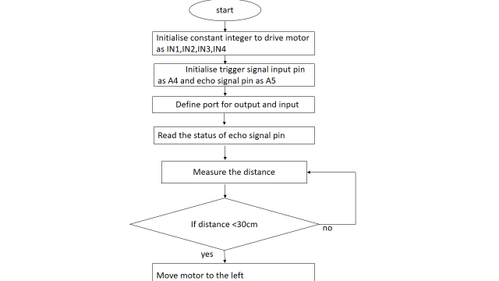

Programming

const int IN1 = 8;

const int IN2 = 9;

const int IN3 = 10;

const int IN4 = 11;

const int trigPin = A4;

const int echoPin = A5;

void setup()

{

 Serial.begin(9600);

 pinMode(trigPin, OUTPUT);

 pinMode(echoPin, INPUT);

 pinMode (IN2, OUTPUT);

 pinMode (IN3, OUTPUT);

 pinMode (IN4, OUTPUT);

 pinMode (IN1, OUTPUT);

}

long duration, distance;

void loop()

{

 digitalWrite(trigPin, LOW);

 delayMicroseconds(2);

 digitalWrite(trigPin, HIGH);

 delayMicroseconds(10);

 digitalWrite(trigPin, LOW);

 duration = pulseIn(echoPin, HIGH);

 distance = duration/58.2;

 Serial.println(distance);

 if(distance<30) // When distance less than 30cm -> Turn Left   {

 digitalWrite(IN1, LOW);

 digitalWrite(IN2, HIGH);

 digitalWrite(IN3, HIGH);

 digitalWrite(IN4, LOW);

 delay(500);

 digitalWrite(IN1, HIGH);

 digitalWrite(IN2, HIGH);

 digitalWrite(IN3, LOW);

 digitalWrite(IN4, LOW);

 delay(1000);

 }

 else

 {

 digitalWrite(IN1, LOW);

 digitalWrite(IN2, HIGH);

 digitalWrite(IN3, LOW);

 digitalWrite(IN4, HIGH);

 }

 delay(100);

}

Hardware

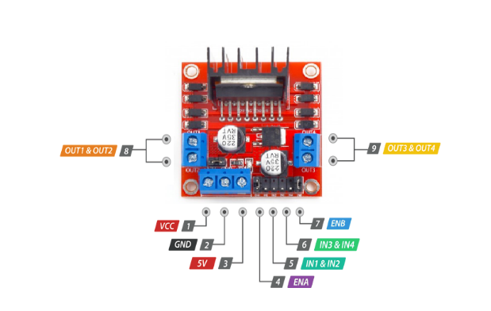

1.connect VCC and GND of sesor module to supply voltage pinn and ground pin of arduino

2. connect trigger signal pin of sensor to the A0 analog input in and echo signal pin to the A1

3.connect L298Dmotor driver module battery connection such as 12 vlt step up converter is used

4.connect ENA and ENB pin driver module to the pin 8 and pin 11 of arduino board.

5.connect digital input pin IN1,IN2 to the 9 pin of arduino

6. connect digital input pin IN3,IN4 to the 10 pin of arduino.

